CHRONIC KIDNEY DISEASE PREDICTION SYSTEM USING MACHINE LEARNING

A PROJECT REPORT
Submitted by
OMSAKTHI A (422522104014)
KEERTHIGA B (422522104021)
JUSNEVIX A (422522104026)
VASUMATHI G (422522104044)

in partial fulfilment for the award of the degree of

BACHELOR OF ENGINEERING IN
COMPUTER SCIENCE AND ENGINEERING


UNIVERSITY COLLEGE OF ENGINEERING VILLUPURAM

ANNA UNIVERSITY :: CHENNAI 600-025

APRIL-2026

ANNA UNIVERSITY :: CHENNAI 600-025

BONAFIDE CERTIFICATE

Certified that this project report “CHRONIC KIDNEY DISEASE PREDICTION SYSTEM USING MACHINE LEARNING.” is the Bonafide work done of “OMSAKTHI A (422522104014), KEERTHIGA B (422522104021), JUSNEVIX A (422522104026), VASUMATHI G (422522104044) " who carried out the project work under my supervision.

SIGNATURE

Dr.R.Regan M.E,Ph.D.,

HEAD OF THE DEPARTMENT

Department of Computer Science and Engineering
University College of Engineering
Villupuram-605103

SIGNATURE
Dr.V.Savitha,Ph.D.,
SUPERVISOR
Department of Computer Science and Engineering
University College of Engineering
Villupuram-605103

Submitted for the University Examination held on………………………...

Internal Examiner External Examiner

ACKNOWLEDGEMENT

We wish to express our sincere thanks and gratitude to our Dean
Dr.R.SENTHIL, Ph.D., for offering us all the facilities to do the project.
We also express our sincere thanks Dr.R.REGAN, M.E.,Ph.D., to Head of the Department, Department of Computer Science and Engineering for his support and guidance to do this project work.
We express our thanks to Dr.V.SAVITHA, Ph.D., our internal project guide for her continuous encouragement and insightful feedback throughout our project journey. Her valuable suggestions and constant motivation greatly contributed to the enhancement of our work.
We would like to thank all the faculty members in our department for their guidance to finish this project successfully. We also like to thank all our friends for their willing assistance.
This project consumed huge amount of work, research and dedication.
Still, implementation would not have been possible if we did not have a support of many individuals and organizations. We would like to extend our sincere gratitude to all of them.

VASUMATHI G
OMSAKTHI A K KEERTHIGA B
JUSNEVIX A

ABSTRACT
Chronic Kidney Disease (CKD) is a serious health condition that gradually reduces kidney function and often shows no clear symptoms in its early stages, making early diagnosis difficult. Early detection is essential to prevent disease progression and improve patient outcomes. This project presents a machine learning-based predictive analytics system for the early identification of CKD using clinical and demographic data. The system analyzes medical parameters such as blood glucose level, serum creatinine, blood urea, packed cell volume, and white blood cell count. Data preprocessing techniques including data cleaning, normalization, and feature selection are applied to enhance model performance and accuracy. Machine learning algorithms such as Logistic Regression and other classification methods are used to identify patterns in patient data. The system is implemented as a web-based application that provides fast, reliable, and real-time predictions to support healthcare professionals in decision -making.

TABLE OF CONTENTS

CHAPTER NO |  | TITLE | PAGE NO
 |  | ABSTRACT  LIST OF FIGURES  LIST OF ABBREVIATIONS | iii  viii  x
1 |  | INTRODUCTION  DOMAIN INTRODUCTION  PROJECT INTRODUCTION | 1  1  1
2 |  | LITERATURE SURVEY  2.1 LITERATURE REVIEW  2.2 REVIEW OF LITERATURE | 3  3  3
3  CHAPTER NO |  | SYSTEM ANALYSIS AND DESIGN  3.1 INTRODUCTION  3.2 EXISTING SYSTEM  3.3 PROPOSED SYSTEM  3.4 SYSTEM DESIGN  3.4.1 ARCHITECTURAL DIAGRAM  3.5 UML DIAGRAM  3.5.1 USE CASE DIAGRAM  3.5.2 COLLABRATION DIAGRAM  TITLE  3.5.3 ACTIVITY DIAGRAM  3.6 DATA FLOW DIAGRAM | 6  6  6  6  7  7  8  9  9  PAGE NO  10  11
4 |  | SYSTEM SPECIFICATION  4.1. REQUIREMENT ANALYSIS  4.2. HARDWARE SPECIFICATIONS  4.3. SOFTWARE SPECIFICATIONS  4.3.1. ANACONDA  4.3.2. SPYDER  4.3.3 HTML  4.3.4 PYTHON | 14  14  14  15  15  16  16  17
5  CHAPTER NO |  | MODULE EXPLAINATION  5.1 LIST OF MODULES  5.1.1 USER INTERFACE MODULE  5.1.2 REPROCESSING MODULE  5.1.3 REGRESSION MODULE  5.1.4 FEATURE SELECTION MODULE  5.1.5 FEATURE EXTRACTION MODULE  TITLE  5.1.6 PREDICTION MODULE  5.1.7 OUTPUT MODULE  5.2 PROPOSED ALGORITHMS  5.2.1 SVM ALGORITHM  5.2.2 DECISION TREE ALGORITHM  5.2.3 RF ALGORITHM | 20  20  20  21  22  23  23  PAGE NO  24  24  25  25  27  31
6 |  | RESULTS AND DISCUSSION  6.1 RESULTS  6.1.1 ACCURACY COMPARISON  6.1.2 BEST MODEL  6.1.3 CONFUSION MATRIX  6.1.4 OUTPUT SCREENSHOT  6.2 DISCUSSION  6.2.1 PERFORMANCE OF ALGORITHM | 33  33  33  33  34  34  35  35
7  CHAPTER NO |  | CONCLUSION AND FUTURE ENCHANCMENT  7.1 CONCLUSION  7.2 FUTURE ENCHANCMENT  TITLE | 38  38  38  PAGE NO
8 |  | APPENDIX  APPENDIX-1 CODING | 39  39
9 |  | REFERENCES | 63

LIST OF FIGURES

 | FIGURE |  | NAME OF THE FIGURE |  | PAGE NO
1.2.1 |  | EARLY DETECTION OF CKD |  | 3
3.4.1 |  | ARCHITECTURE DIAGRAM |  | 9
3.5 |  | UML DIAGRAM |  | 9
3.5.1 |  | USE CASE DIAGRAM |  | 10
3.5.2 |  | COLLABRATION DIAGRAM |  | 11
3.5.3 |  | ACTIVITY DIAGRAM |  | 12
3.6.1 |  | DFD LEVEL 0 |  | 13
3.6.2 |  | DFD LEVEL 1 |  | 13
3.6.3 |  | DFD LEVEL 2 |  | 14
5.1.1 |  | PREPROCESSING DIAGRAM |  | 22
5.1.2 |  | LOGISTIC REGRESSION MODEL |  | 23
5.2.1 |  | SUPPORT VECTOR MACHINCE |  | 28
5.2.2 |  | RANDOM FOREST TREE |  | 31
5.2.3 |  | RANDOM FOREST |  | 33
6.1.1 |  | ACCURACY COMPARARSION |  | 34
6.1.2 |  | OPENING WINDOW |  | 35
6.1.3 |  | CKD PREDICTION |  | 36
6.2.1  6.2.2  6.2.3  6.2.4 |  | PERFORMANCE OF ALGORITHM  SUPPORT VECTOR MACHINCE  LOGISTIC REGRESSION MODEL  RANDOM FOREST TREE  VARIABLE PLOT |  | 37  37  37  38  38

LIST OF ABBREVIATIONS

ABBREVIATIONS | EXPANSION
ML | MACHINCE LEARNING.
CKD | CHRONIC KIDNEY DISEASE.
CKDPS | CHRONIC KIDNEY DISEASE PREDICTION SYSTEM
SVM | SUPPORT VECTOR MACHINCE.
RFT | RANDOM FOREST TREE.
GUI | GRAPHICAL USER INTERFACE.
DFD | DATA FLOW DIAGRAM
ESRD | END STAGE RENAL DISEASE

CHAPTER 1

INTRODUCTION

  - DOMAIN INTRODUCTION
Chronic Kidney Disease affects millions of people worldwide and has become a major public health concern. The disease develops slowly over time and often remains unnoticed during the early stages because symptoms are minimal or absent.

According to several health organizations, many CKD cases are detected only when the disease reaches an advanced stage. At this point, treatment becomes more difficult and expensive, sometimes requiring dialysis or kidney transplantation.

Early diagnosis is therefore very important. Detecting CKD in its early stages allows patients to receive timely treatment, adopt healthy lifestyle changes, and prevent further kidney damage.

Recent advancements in Artificial Intelligence (AI) and Machine Learning (ML) have introduced new opportunities in the medical field. Predictive analytics uses patient data, medical records, and historical health information to identify patterns and predict disease risk.

By analyzing Electronic Health Records (EHRs), laboratory results, demographic information, and lifestyle factors, machine learning models can identify individuals who are at risk of developing CKD. This approach supports healthcare providers in making better decisions and enables preventive healthcare strategies.

PROJECT INTRODUCTION
The primary purpose of this project is to demonstrate how data-driven predictive analytics can be used to detect Chronic Kidney Disease at an early stage.The main purpose of this application is to utilize data-driven predictive analytics to enable the early detection of Chronic Kidney Disease (CKD). Traditional diagnostic methods often identify CKD only after the disease has progressed to an advanced stage, which limits treatment options and increases healthcare costs. By applying machine Learning techniques to health data, the proposed system aims to identify individuals who are at risk of developing CKD at an earlier stage. Early prediction allows healthcare providers to take preventive actions and provide timely medical intervention.
The application focuses on improving diagnostic accuracy by analyzing various medical parameters such as laboratory test results, patient demographic information, and clinical indicators. By combining different data sources, including Electronic Health Records (EHRs), medical reports, and patient history, the system can identify patterns that may indicate the early presence of CKD. Machine learning algorithms are used to analyze this data and generate predictions that support doctors in making informed clinical decisions.
In addition, the system promotes preventive healthcare by helping patients understand their health risks and encouraging early monitoring. By providing accurate predictions and real-time results, the application assists healthcare professionals in planning appropriate treatments and improving patient outcomes. Overall, the objective of this application is to support early disease detection, enhance decision-making in healthcare, and reduce the long-term burden of Chronic Kidney Disease.



Fig 1.2.1 : EARLY DETECTION OF CKD

CHAPTER 2

LITERATURE SURVEY

LITERATURE REVIEW
The literature review focuses on previous research studies related to the early detection of Chronic Kidney Disease using machine learning techniques.
Several studies have shown that machine learning models can significantly improve the accuracy of CKD prediction. These models analyze medical datasets and identify patterns that indicate possible kidney disease.
Researchers have developed different predictive models such as hybrid machine learning models, deep learning approaches, and explainable AI techniques to improve prediction performance. These models can be integrated into clinical systems to assist doctors in diagnosing CKD earlier. However, challenges such as data quality, privacy concerns, and ethical considerations still exist.

REVIEW OF LITERATURE

SURVEY-1:

Title: Identifying important attributes for early detection of Chronic Kidney Disease.
Author: Anandanadarajah Nishanth and Tharmarajah Thiruvaran.
Year: 2024.
Description: They proposed the If the important attributes that could help to detect CKD is known then even people who are not diagnosed CKD also may get a clue of the condition of their kidney from the medical test that they took for some other purposes. Then they may proceed to properly check for CKD. A weighting vector based on CSP filter and LDA analysis and then classification analysis using LDA and KNN classifiers were used to identify the dominant attributes. It is found that hemoglobin, albumin, specific gravity, serum creatinine, hypertension and diabetes mellitus are the most important attributes in detecting CKD.

SURVEY-2:

Title: A Deep Learning-based System for Automated Sensing of Chronic Kidney Disease.
Author: Navaneeth Bhaskar and Suchetha M.
Year:2023.
Description: They have proposed and investigated a new sensing model for prompt and accurate diagnosis of CKD. The raw sensor signal is directly given to the deep learning algorithm for predictive decision making. The proposed 1-D CNN-SVM algorithm extracted features directly from the raw signal and successfully classified the samples with an accuracy of 98.04%. The proposed sensing approach is tested and validated by the physician.They have performed the statistical analysis to determine how well the proposed sensing method values and traditional urea estimation values are correlated. A positive correlation is observed between the two values with r and R2 values of 0.9898 and 0.9799 respectively. The experimental evaluation results show that the proposed sensing module can be successfully used with the capabilities of deep learning techniques for detecting CKD more effectively than traditional methods.

SURVEY-3:

Title: In vivo detection of chronic kidney disease using tissue deformation fields from dynamic MR imaging.
Author: Erlend Hodneland1, Eirik Keilegavlen, Erik A. Hanson, Erling Andersen, Jan Ankar Monssen, Jarle Rørvik.
Year: 2022.
Description: They proposed a framework for detecting pathological changes in stiffness using image registration. Our findings are based on a small cohort, and need to be verified in a larger clinical study. Still, initial results indicate that the absolute deformation, normalized volume changes, as well as pressure gradients demonstrate a statistical correlation to arteriosclerosis in the kidneys, and hence could be used as a proxy for arteriosclerosis grade. The simulation study indicated that image registration has a borderline sensitivity close to the stiffness changes seen in mild CKD.

SURVEY-4:

Title: Erythropoietin Dose Optimization for Anemia in Chronic Kidney Disease Using Recursive Zone Model Predictive Control.
Author: Jayson McAllister, Zukui Li, Jinfeng Liu and Ulrich Simonsmeier.
Year:2022.
Description: They proposes a novel modeling and control algorithm, based on recursive weighted constrained ARX modeling and ZMPC, for the regulation of hemoglobin concentration in patients with CKD undergoing ESA treatment. This paper compares the performance of several different modeling techniques on actual clinical data, showing that the chosen modeling method provides sufficient modeling accuracy, while being less complex and able to be solved with a more robust optimization solver.

SURVEY-5:

Title: Mechanical Anisotropy Assessment in Kidney Cortex Using ARFI Peak Displacement: Preclinical Validation and Pilot In Vivo Clinical Results in Kidney Allografts.
Author: Jayson McAllister, Zukui Li, Jinfeng Liu and Ulrich Simonsmeier.
Year:2021.
Description: The clinical feasibility of ARFI-PD ratio as a measure of mechanical anisotropy in the allografts of renal transplant patients. In healthy allografts, PD ratios were stable over two, four, and six months post-transplantations. Preclinical validation studies in pig kidneys showed that PD-ratios linearly correlated with SWEI-derived shear moduli ratios ex vivo as well as in vivo at baseline, with arterial ligation, and with venous ligation. Further, mechanical anisotropy was exploited by using an asymmetrical ARF, but a symmetric ARF generally obviated anisotropy and enabled angle independent mechanical property assessment in the anisotropic cortex. Thus, when mechanical anisotropy is of interest as a renal biomarker, an asymmetric ARF should be implemented.

CHAPTER 3

SYSTEM ANALYSIS AND DESIGN

INTRODUCTION

- Chronic kidney disease, also called chronic kidney failure, describes the gradual loss of kidney function. Your kidneys filter wastes and excess fluids from your blood, which are then excreted in your urine. When chronic kidney disease reaches an advanced stage, dangerous levels of fluid, electrolytes and wastes can build up in your body.
- In the early stages of chronic kidney disease, you may have few signs or symptoms. Chronic kidney disease may not become apparent until your kidney function is significantly impaired.
- Treatment for chronic kidney disease focuses on slowing the progression of the kidney damage, usually by controlling the underlying cause. Chronic kidney disease can progress to end-stage kidney failure, which is fatal without artificial filtering (dialysis) or a kidney transplant.
- The early stage of Chronic kidney Disease can predict using machine learning techniques.

EXISTING SYSTEM

Traditional CKD diagnosis mainly depends on laboratory tests and medical examinations. Electronic Health Records store patient medical history and clinical data, which help doctors analyze patient health.
Clinical Decision Support Systems assist healthcare professionals by providing recommendations based on patient data.

PROPOSED SYSTEM

- The proposed system, uses machine learning algorithm to predict CKD for Indian set.

- By using Feature selection and feature extraction minimal number of feature will be required for the prediction.
- To achieve this we have planned to approach by three feature selection algorithm with combination of two feature Extraction algorithm.
- After performing feature selection and Feature Extraction, those features will be trained with different Machine Learning algorithm.
- The accuracy of best combination algorithm will be implemented for predicting the CKD.
- The dataset is collected from Kaggle machine learning database, obtained by the survey of CKD in India that contains laboratory results of both positive and negative cases of CKD. It contains cases of 400 patients with 25 attributes (eg, red blood cell count, white blood cell count, etc.).
- Input attributes are used to take input from user in CKDPS and output attribute is for diagnosis result.
- To classify that patient has CKD or Not CKD according to the values of input attributes
the output attribute “Classification” is set as the target class.
- Except the target class column, the entire dataset is divided into two sets in 7:3 ratios. 70% of which is used for training the machine learning algorithms and the 30% is used to test their accuracy, precision and recall.

SYSTEM DESIGN

ARCHITECTURAL DIAGRAM
An architecture diagram is a graphical representation of a set of concepts, are part of an architecture, including their principles, elements and components.
There are many kinds of architecture diagrams, like software architecture diagram, system architecture diagram, application architecture diagram, security architecture diagram, etc. A system architecture or systems architecture is the conceptual model that defines the structure, behavior, and more views of a system. An architecture description is a formal description and representation of a system, organized in a way that supports reasoning about the structures and behavior of the system.
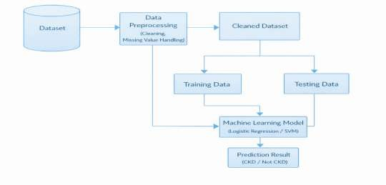
The training data is used to train the machine learning model, while the testing data is used to evaluate the performance of the model. Machine learning algorithms such as Logistic Regression or Support Vector Machine (SVM) analyze the medical parameters and learn patterns from the dataset. Finally, the trained model generates a prediction result that indicates whether the patient has Chronic Kidney Disease or not.

Fig 3.4.1: ARCHITECTURE DIAGRAM.

UML DIAGRAM

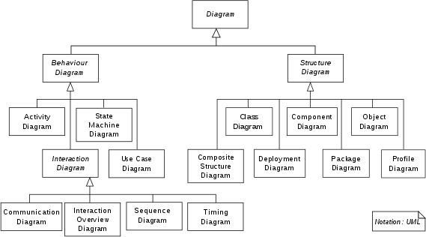
The Unified Modeling Language (UML) is a general-purpose, developmental, modeling language in the field of software engineering that is intended to provide a standard way to visualize the design of a system.

Fig 3.5.1: UML DIAGRAM.

USE CASE DIAGRAM

The use case diagram represents the workflow of the Chronic Kidney Disease prediction system. The dataset is collected and processed, followed by feature selection and model training using machine learning techniques. The trained model is then used in the predicting system to generate results. The system is accessed by doctors, researchers, patients, and common users, through whom prediction outputs are obtained for decision-making.
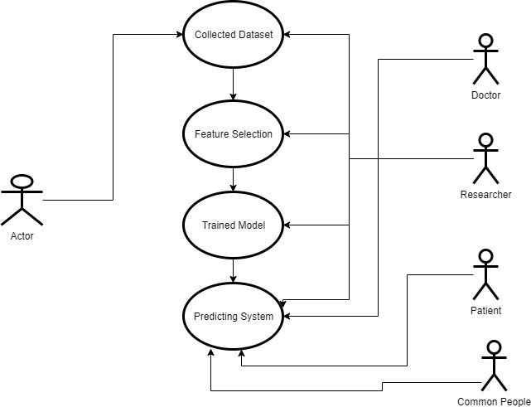

Fig 3.5.2: USE CASE DIAGRAM.

COLLABRATION DIAGRAM

The collaboration diagram represents the overall workflow of the Chronic Kidney Disease prediction system. Initially, data is collected and preprocessing is performed as part of data engineering. The processed data is then passed to feature engineering, where important features are selected. Further, machine learning algorithms are applied, and supervised learning techniques are used to build the model. The model is evaluated based on its performance in classification tasks. Finally, the trained model is integrated into the front-end web application, where prediction results are displayed to the user.

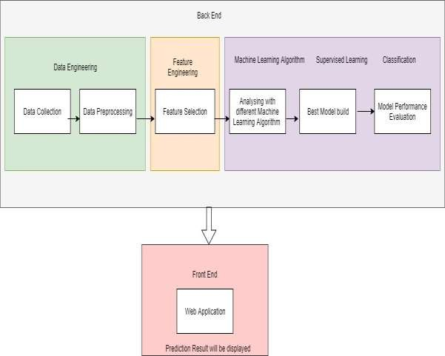
Fig 3.5.2: COLLABRATION DIAGRAM.

ACTIVITY DIAGRAM

The activity model represents the step-by-step workflow of the Chronic Kidney Disease prediction system. Initially, input data is provided by the user, and the data is collected and preprocessed to remove errors and inconsistencies. Feature selection is then performed to identify important medical attributes. The processed data is passed to machine learning algorithms, where the model is trained and predictions are generated. Based on the prediction results, the output is displayed to the user through the web application. All activities are carried out in a sequential flow to ensure accurate and efficent.

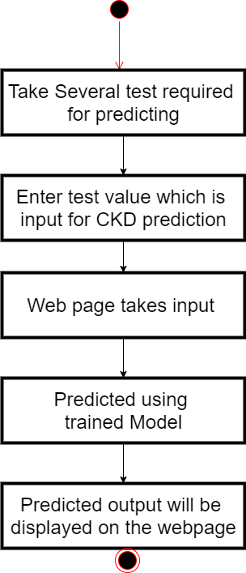

Fig 3.5.4: ACTIVITY DIAGRAM.

3.6 DATA FLOW DIAGRAM
The Data Flow Diagram represents the data is processed within the Chronic Kidney Disease prediction system. Initially, input data is provided by the user and is collected by the system. The data is then processed through preprocessing steps to remove errors and normalize values. Feature selection is performed to extract important attributes from the data. The processed data is passed to the machine learning model, where predictions are generated. Finally, the prediction results are displayed to the user through the web application. The flow of data is maintained systematically between different components to ensure accurate and efficient processing.

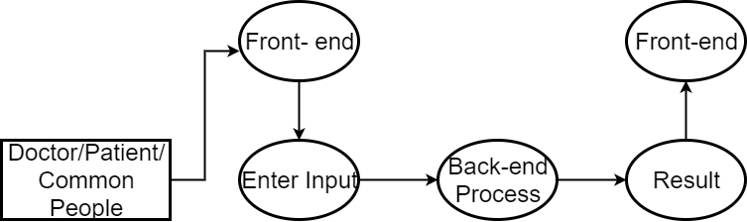

Fig 3.6.1: DFD Level 0.
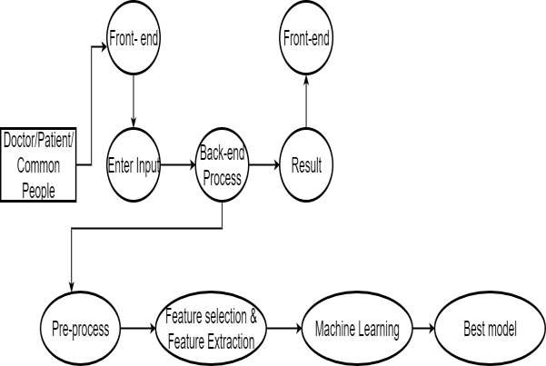

Fig 3.6.2: DFD Level 1.

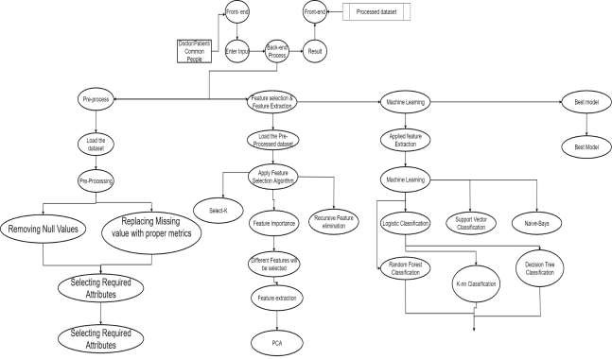

CHAPTER 4

SYSTEM SPECIFICATIONS

System specifications is a structured collection of information that embodies the requirements of a system. The System Specification describes the functional and non- functional requirements posed on a system element (system, Enabling System or segment). In order to prepare the System Specification, the requirements will be derived from the specifications of higher system elements or from the Overall System Specification.

REQUIREMENT ANALYSIS

Requirement analysis is an important phase in system and software engineering. It focuses on identifying the needs and conditions required to develop a new system or improve an existing system. This process involves understanding the requirements of different stakeholders, analyzing the system needs, documenting them properly, and validating them before development begins.
Requirement analysis plays a critical role in the success of any software project. The requirements should be clearly documented so that they are measurable, testable, and traceable. Proper requirement analysis ensures that the developed system satisfies business needs and provides a strong foundation for system design and development.

HARDWARE SPECIFICATIONS

Hardware requirements is the most common set of requirements defined by any operating system or software application is the physical computer resources, also known as hardware, A hardware requirements list is often accompanied by a hardware compatibility list (HCL), especially in case of operating systems.
- Processor: Intel i3 or equivalent AMD processor
- RAM: 4 GB (minimum for 64-bit system)
- Hard Disk: 250 GB available space
- Display Resolution: 1200 × 800 pixels

SOFTWARE SPECIFICATIONS
Software specifications define the software tools, platforms, and programming environments required to develop and run the application. These software components must be installed on the computer system to ensure proper functioning of the application.
Software requirements help in organizing and managing the development process. They also assist in communication between developers and stakeholders. These requirements include programming languages, frameworks, platforms, and development tools used in building the system.
The software requirements for this project are:
- Operating System: Windows 8 / 8.1 / 10
- Platform: Anaconda
- Text Editor: Spyder
- Framework: Django
- Programming Languages: Python, HTML, CSS, Bootstrap

ANACONDA
Anaconda is a free and open source distribution of the Python and R programming languages for scientific computing (data science, machine learning applications, large-scale data processing, predictive analysis, etc.), that aims to simplify package management and deployment. Package versions are managed by the package management system conda. The Anaconda distribution includes data-science packages suitable for Windows, Linux, and MacOS.
Anaconda Navigator is a desktop Graphical User Interface(GUI) included in Anaconda distribution that allows users to launch applications and manage conda packages, environments and channels without using command-line commands. Navigator can search for packages on Anaconda Cloud or in a local Anaconda Repository, install them in an environment, run the packages and update them. It is available for Windows, macOS and Linux.
Anaconda Cloud is a package management service by Anaconda where you can find, access, store and share public and private notebooks, environments, and conda and PyPI packages.Cloud hosts useful Python packages, notebooks and environments for a wide variety of applications.
Building a new packages using the Anaconda Client command line interface (CLI), then manually or automatically upload the packages to Cloud.

SPYDER
Spyder is an open-source Integrated Development Environment (IDE) designed for scientific programming in Python. It provides an easy and interactive environment for writing, testing, and debugging Python programs.
Spyder supports several important Python libraries such as NumPy, SciPy, Matplotlib, Pandas, IPython, and SymPy. It is widely used in data science and machine learning projects.
Spyder was initially developed by Pierre Raybaut in 2009 and later maintained by a team of scientific Python developers.
Key features of Spyder include:
      - Syntax highlighting and code completion
      - Support for multiple IPython consoles
      - Graphical variable explorer
      - Built-in debugger for step-by-step execution
      - Static code analysis using Pylint
      - File explorer for project management
      - Integrated help documentation
      - Runtime profiler for performance analysis
Spyder is available on Windows, macOS, and Linux platforms and is commonly installed through the Anaconda distribution.

DJANGO
Django is a high-level Python web framework used for developing secure and scalable web applications. It was created in 2003 by web developers Adrian Holovaty and Simon Willison and later maintained by the Django Software Foundation (DSF).
Django follows the Model–View–Controller (MVC) architecture pattern, which separates application logic into different components. The framework includes an Object Relational Mapper (ORM) that allows developers to interact with databases using Python code instead of SQL queries.
Some important features of Django include:
      - Built-in lightweight development server
      - Form validation and data processing system
      - Template engine for dynamic web page creation
      - Caching framework for improved performance
      - Middleware support for request processing
      - Internationalization support for multiple languages
      - Serialization support for XML and JSON formats
      - Built-in unit testing framework
      - Support for creating REST APIs using Django REST Framework
These features make Django a powerful framework for developing web-based applications.

4.3.4 HYPER TEXT MARKUP LANGUAGE(HTML)

- Hypertext Markup Language (HTML) is the standard markup language for documents designed to be displayed in a web browser. It can be assisted by technologies such as Cascading Style Sheets (CSS) and scripting languages such as JavaScript.
- Web browsers receive HTML documents from a web server or from local storage and render the documents into multimedia web pages. HTML describes the structure of a web page semantically and originally included cues for the appearance of the document. HTML can embed programs written in a scripting language such as JavaScript, which affects the behavior and content of web pages. Inclusion of CSS defines the look and layout of content.
- HTML markup consists of several key components, including those called tags (and their attributes), character-based data types, character references and entity references. HTML tags most commonly come in pairs like <h1> and </h1>, although some represent empty elements and so are unpaired, for example <img>. The first tag in such a pair is the start tag, and the second is the end tag (they are also called opening tags and closing tags).
- Another important component is the HTML document type declaration, which triggers standards mode rendering.

4.3.5 PYTHON
Python is interpreted, high-level, general-purpose programming language. Created by Guido van Rossum and first released in 1991, Python's design philosophy emphasizes code readability with its notable use of significant whitespace. Its language constructs and object-oriented approach aim to help programmers write clear, logical code for small and large-scale projects. It is dynamically typed and garbage-collected. It supports multiple programming paradigms, including procedural, object-oriented, and functional programming. Python is often described as a "batteries included" language due to its comprehensive standard library. Python interpreters are available for many operating systems. A global community of programmers develops and maintains CPython, an open source reference implementation.
Elements:
HTML documents imply a structure of nested HTML elements. These are indicated in the document by HTML tags, enclosed in angle brackets thus: <p>.
In the simple, general case, the extent of an element is indicated by a pair of tags: "start tag" <p> and "end tag" </p> . The text content of the element, if any, is placed between these tags.
Tags may also enclose further tag markup between the start and end, including a mixture of tags and text. This indicates further (nested) elements, as children of the parent element.
The start tag may also include attributes within the tag. These indicate other information, such as identifiers for sections within the document, identifiers used to bind style information to the presentation of the document, and for some tags such as the reference to the image resource. used to embed images, the
Some elements, such as the line break <br> , do not permit any embedded content, either text or further tags. These require only a single empty tag (akin to a start tag) and do not use an end tag.
Many tags, particularly the closing end tag for the very commonly used paragraph element <p> , are optional. An HTML browser or other agent can infer the closure for the end of an element from the context and the structural rules defined by the HTML standard. These rules are complex and not widely understood by most HTML coders.
<tag attribute1="value1" attribute2="value2">''content''</tag> . Some HTML elements are defined as empty elements and take the form <tag attribute1="value1" attribute2="value2"> .
Empty elements may enclose no content, for instance, the tag or the inline tag.
The name of an HTML element is the name used in the tags. Note that the end tag's name is preceded by a slash character, / , and that in empty elements the end tag is neither required nor allowed. If attributes are not mentioned, default values are used in each case.

CHAPTER 5

MODULE EXPLAINATION

LIST OF MODULES

USER INTERFACE MODULE
The user interface (UI), in the industrial design field of human-computer interaction, is the space where interactions between humans and machines occur. The goal of this interaction is to allow effective operation and control of the machine from the human end, whilst the machine simultaneously feeds back information that aids the operators' decision- making process. Examples of this broad concept of user interfaces include the interactive aspects of computer operating systems, hand tools, heavy machinery operator controls, and process controls. The design considerations applicable when creating user interfaces are related to or involve such disciplines as ergonomics and psychology.
Generally, the goal of user interface design is to produce a user interface which makes it easy, efficient, and enjoyable (user-friendly) to operate a machine in the way which produces the desired result. This generally means that the operator needs to provide minimal input to achieve the desired output, and also that the machine minimizes undesired outputs to the human. Human sense, including: tactile UI (touch), visual UI (sight), auditory UI (sound), olfactory UI (smell), equilibrial UI (balance), and gustatory UI (taste).
User interface plays a crucial role in improving user satisfaction and system efficiency by ensuring smooth interaction between the user and the application. In the Chronic Kidney Disease prediction system, the interface is designed to reduce complexity by presenting information in a clear and organized manner. This helps users to quickly understand the results and interact with the system without confusion, thereby enhancing overall usability
User interfaces are composed of one or more layers including a human-machine interface (HMI) interfaces machines with physical input hardware such as keyboards, mice, game pads and output hardware such as computer monitors, speakers, and printers. A device that implements an HMI is called a human interface device (HID). Other terms for human- machine interfaces are man-machine interface (MMI) and when the machine in question is a computer human-computer interface. Additional UI layers may interact with one or more human sense, including: tactile UI (touch), visual UI (sight), auditory UI (sound), olfactory UI (smell), equilibrial UI (balance), and gustatory UI (taste).

PREPROCESSING MODULE

Pre-processing refers to the transformations applied to our data before feeding it to the algorithm. Data Preprocessing is a technique that is used to convert the raw data into a clean data set. In other words, whenever the data is gathered from different sources it is collected in raw format which is not feasible for the analysis.
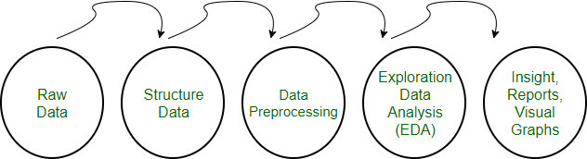
Fig 5.1.1: PREPROCESSING DIAGRAM.

Need of Data Preprocessing
For achieving better results from the applied model in Machine Learning projects the format of the data has to be in a proper manner. Some specified Machine Learning model needs information in a specified format, for example, Random Forest algorithm does not support null values, therefore to execute random forest algorithm null values have to be managed from the original raw data set. Another aspect is that data set should be formatted in such a way that more than one Machine Learning and Deep Learning algorithms are executed in one data set, and best out of them is chosen.
- Rescale Data
When our data is comprised of attributes with varying scales, many machine learning algorithms can benefit from rescaling the attributes to all have the same scale.This is useful for optimization algorithms in used in the core of machine learning algorithms like gradient descent. It is also useful for algorithms that weight inputs like regression and neural networks and algorithms that use distance measures like K-Nearest Neighbors. Rescale the data using scikit-learn the MinMax Scalar class.

- Binarize Data (Make Binary)
  - It can transform our data using a binary threshold. All values above the threshold are marked 1 and all equal to or below are marked as 0.
  - This is called binarizing your data or threshold your data. It can be useful when you have probabilities that you want to make crisp values. It is also useful when feature engineering and you want to add new features that indicate something meaningful.
  - It can create new binary attributes in Python using scikit-learn with the Binarizer class.

- Standardize Data
Standardization is a useful technique to transform attributes with a Gaussian distribution and differing means and standard deviations to a standard Gaussian distribution with a mean of 0 and a standard deviation of 1.
It can standardize data using scikit-learn with the Standard Scalar class.

CLASSIFICATION/REGRESSION MODULE
A regression problem is when the output variable is a real or continuous value, such as “salary” or “weight”. Many different models can be used, the simplest is the linear regression. It tries to fit data with the best hyper-plane which goes through the points.
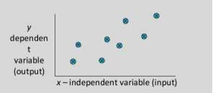
Fig 5.1.2: REGRSSION MODEL.

Example
- Predicting age of a person
- Predicting nationality of a person
- Predicting whether stock price of a company will increase tomorrow
- Predicting whether a document is related to sighting of UFOs
Predicting age of a person (because it is a real value, predicting nationality is categorical, whether stock price will increase is discrete-yes/no answer, predicting whether a document is related to UFO is again discrete- a yes/no answer).

FEATURE SELECTION MODULE

A feature selection algorithm can be seen as the combination of a search technique for proposing new feature subsets, along with an evaluation measure which scores the different feature subsets. The simplest algorithm is to test each possible subset of features finding the one which minimizes the error rate. This is an exhaustive search of the space, and is computationally intractable for all but the smallest of feature sets. The choice of evaluation metric heavily influences the algorithm, and it is these evaluation metrics which distinguish between the three main categories of feature selection algorithms: wrappers, filters and embedded methods.
Univariate feature selection works by selecting the best features based on univariate statistical tests. It can be seen as a preprocessing step to an estimator. Scikit-learn exposes feature selection routines as objects that implement the transform method:

SelectKBest removes all but the k highest scoring features.

FEATURE EXTRACTION MODULE

In machine learning, pattern recognition and in image processing, feature extraction starts from an initial set of measured data and builds derived values (features) intended to be informative and non-redundant, facilitating the subsequent learning and generalization steps, and in some cases leading to better human interpretations. Feature extraction is related to dimensionality reduction.

Understanding the math behind Principal Component Analysis (PCA) without a solid linear algebra foundation is challenging. When I taught Data Science at General Assembly in San Francisco, I found that helping students visualize the transformation between features and principal components greatly enhanced their understanding. PCA is a dimensionality reduction technique that has four main parts: feature covariance, eigende composition, principal component transformation, and choosing components in terms of explained variance.

PREDICTION MODULE

Predictive modeling is a process that uses Data Mining and probability to forecast outcomes. Each model is made up of a number of predictors, which are variables that are likely to influence future results. Once data has been collected for relevant predictors, a statistical model is formulated. The model may employ a simple linear equation, or it may be a complex neural network, mapped out by sophisticated software. As additional data becomes available, the statistical analysis model is validated or revised.
Modeling methods

Although it may be tempting to think that big data makes predictive models more accurate, statistical theorems show that, after a certain point, feeding more data into a predictive analytics model does not improve accuracy. Analyzing representative portions of the available information -- sampling -- can help speed development time on models and enable them to be deployed more quickly.

Once data scientists gather this sample data, they must select the right model. Linear regressions are among the simplest types of predictive models. Linear models essentially take two variables that are correlated -- one independent and the other dependent -- and plot one on the x-axis and one on the y-axis. The model applies a best fit line to the resulting data points. Data scientists can use this to predict future occurrences of the dependent variable.

OUTPUT MODULE

Output for the given model is predicted by matching the given input and the preprocessed data. Preprocessed data consist of both training set and testing set. Given input is loaded according to the preprocessed data. Based on the comparision, output is predicted along with its accuracy and loss. This process is carried out in both the RF Algorithm, SVM Algorithm, KNN Algorithm, NB Algorithm, DT Algorithm thus it results in ROC curve (diagrammatic representation).ROC curve compares both the results and contrast its accuracy.

PROPOSED ALGORITHMS

    - SUPPORT VECTOR MACHINCE(SVM)
Support Vector Machines (SVM) have recently gained prominence in the field of machine learning and pattern classification. Classification is achieved by realizing a linear or non-linear separation surface in the input space. The DirectSVM is an intuitively appealing algorithm, which builds the Support Vector set incrementally . Recently it has been proved that the closest pair of points of the opposite class are always Support Vectors. DirectSVM starts off with this pair of points in the candidate Support Vector set. The Geometric SVM proposed by us improves the scaling behavior of the DirectSVM by using an optimization based approach to add points to the candidate Support Vector set.
Three main ideas:

- Define what an optimal hyperplane is (taking into account that it needs to be computed efficiently): maximize margin
- Generalize to non-linearly separable problems: have a penalty term for misclassifications

- Map data to high dimensional space where it is easier to classify with linear decision surfaces: reformulate problem so that data are mapped implicitly to this space.
Soft vs Hard margin in SVM

Soft-Margin always has a solution • Soft-Margin is more robust to outliers – Smoother surfaces (in the non-linear case) • Hard-Margin does not require to guess the cost parameter (requires no parameters at all)

  - SVMs that perform regression and also clustering .

  - Support Vector Machines: maximize margin while bounding the number of margin errors.

  - Leave One Out Machines: minimize the bound of the leave-one-out error.

  - SVM formulations that allow different cost of misclassification for different classes.

  - Kernels suitable for sequences of strings, or other specialized kernels.

  - Very successful.

  - Other formulations exist where minimizing the number of variables is folded into the
optimization problem.

  - Similar algorithms for non-linear SVMs.

  - Quite successful.

SVMs formulate learning as a mathematical program taking advantage of the rich theory in optimization.
  - SVM uses kernels to map indirectly to extremely high dimensional spaces.

  - SVMs are extremely successful, robust, efficient, and versatile, and have a good theoretical
basis.

SVM ALGORITHM
candidateSV = { closest pair from opposite classes }

while there are violating points do

Find a violator

candidateSV = candidateSV U violator

if any ap < 0 due to addition of c to S then

candidateSV = candidateSV \ p repeat till all such points are pruned end if
end while

Recursive Feature Elimination –

Train a linear SVM – Remove the x% of variables with the lowest weights (those variables affect classification the least) – Retrain the SVM with remaining variables and repeat until classification quality is reduced.
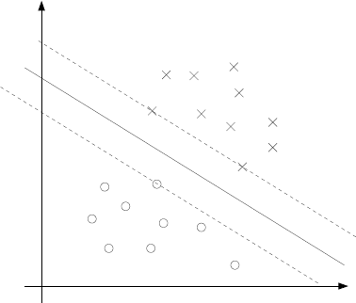
Fig 5.2.1: SVM

5.2.2 LOGISTIC REGRESSION MODEL
Logistic regression analysis can be divided into simple logistic regression and multiple logistic regression. The paper will mainly analyze simple logistic regression model that is the analysis method of studying the relations between independent variable and dependent variable. We will set the model of dependent variable y and the independent variable (i=1,2,3……) that will influence the variable y and the predict the development trend of y
,Simple logistic regression model will be expressed as followed: a ax e y is the dependent variable and x is the independent+ +=0 1 y variable. 0 a , the constant term, is the intercept of the regression line on the vertical axis and 1 a is regression coefficient that is the slope of the regression line. e is the random error which will be used to express the effect of random factors on dependent variable.

Logistic regression assumes a linear or straight line relationship between the input variables (X) and the single output variable (y).More specifically, that output (y) can be calculated from a linear combination of the input variables (X). When there is a single input variable is referred to as a simple logistic regression.In simple linear regression we can use statistics on the training data to estimate the coefficients required by the model to make predictions on new data.

The line for a simple linear regression model can be written as:

y = b0 + b1 * x

where b0 and b1 are the coefficients we must estimate from the training data.Once the coefficients are known, we can use this equation to estimate output values for y given new input examples of x.
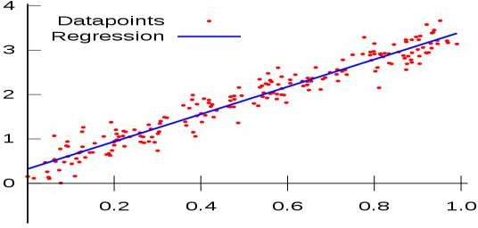

Fig 5.2.2: LOGISTIC REGRESSION MODEL

5.2.3 RANDOM FORESR ALGORITHM(RF)

Random Forests were introduced by Leo Breiman who was inspired by earlier work by Amit and Geman. Although not obvious from the description in , Random Forests are an extension of Breiman’s bagging idea and were developed as a competitor to boosting. Random Forests can be used for either a categorical response variable, referred to in as “classification”, or a continuous response, re- ferred to as “regression”. Similarly, the predictor variables can be either categorical or continuous. From a computational standpoint,
Random Forests are appealing because they

- Naturally handle both regression and (multiclass) classification;

      - are relatively fast to train and to predict;

      - depend only on one or two tuning parameters;

      - have a built in estimate of generalization error;

      - can be used directly for high-dimensional problems;

      - can easily be implemented in parallel.

- Statistically, Random Forests are appealing because of the additional features they provide, such as
      - measures of variable importance;

      - differential class weighting;

      - missing value imputation;

      - visualization;

      - outlier detection

      - unsupervisedAlgorithm

Random forest Algorithm
Algorithm Random Forests
Let D = {(x1,y1),...,(xN,yN)} denote the training data, with xi = (xi,1,...,xi,p)T. For j = 1 to J:
- Take a bootstrap sample Dj of size N from D.

- Using the bootstrap sample Dj as the training data, fit a tree using binary recursive
partitioning :

  - Start with all observations in a single node

  - Repeat the following steps recursively for each unsplit node until the stopping criterion is met

    - Select m predictors at random from the p available predictors.

    - Find the best binary split among all binary splits on the m predictors from step,

    - Split the node into two descendant nodes using the split from step

iv. To make a prediction at a new point x,

ˆ f(x) = 1 J ∑J j=1 ˆ hj(x) for regression

ˆ f(x) = argmaxy∑J j=1 I(ˆ hj(x) = y) for classification

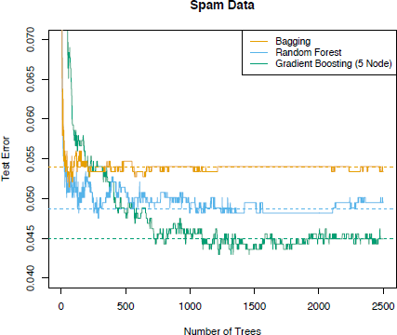
where ˆ hj(x) is the prediction of the response variable at x using the jth tree.

CHAPTER 6

RESULTS AND DISCUSSION

6.1 RESULTS

6.1.1 ACCURACY COMPARISON

The accuracy results of the proposed system were evaluated using different machine learning algorithms such as Logistic Regression, Support Vector Machine (SVM), and Random Forest. The performance of each model was compared based on its ability to correctly predict the presence of Chronic Kidney Disease (CKD). The results showed that Logistic Regression achieved an accuracy of approximately 85%, Support Vector Machine achieved around 88%, and Random Forest achieved the highest accuracy of approximately 92%. These results clearly indicate that the Random Forest algorithm performs better than the other models in terms of prediction accuracy.

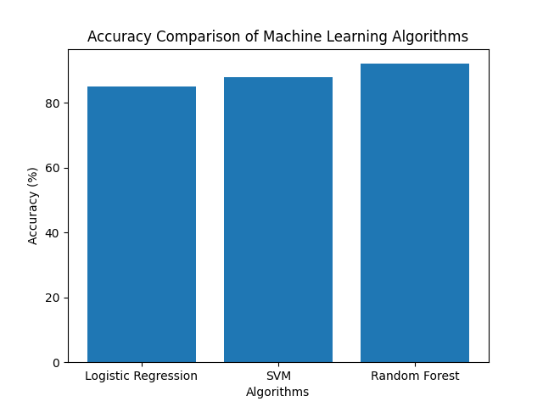
Fig 6.1.1: ACCURACY COMPARSION

6.1.2 BEST MODEL

Among all the classification algorithms used in the system, Random Forest was identified as the best-performing model. This is because it achieved the highest accuracy compared to Logistic Regression and SVM. The ensemble nature of Random Forest, which combines multiple

decision trees, helps in improving prediction performance and reducing errors. Therefore, Random Forest was selected as the final model for deployment in the system to provide more reliable and accurate predictions.

6.1.3 CONFUSION MATRIX

The confusion matrix was used to evaluate the classification performance of the model in detail. It provides information about True Positive (TP), True Negative (TN), False Positive (FP), and False Negative (FN) values. The results from the confusion matrix showed that the model was able to correctly classify most of the CKD and non-CKD cases, with a higher number of true predictions and fewer misclassifications. This indicates that the system has good predictive capability and can be considered reliable for CKD prediction.
Actual / Predicted | Predicted CKD | Predicted No CKD
Actual CKD | TP (True Positive) | FN (False Negative)
Actual No CKD | FP (False Positive) | TN (True Negative)


6.1.4 OUTPUT SCREEN

Fig 6.1.2: OPENING WINDOW



Fig 6.1.3: CKD prediction

6.2 DISCUSSION

The discussion of the results explains the reasons behind the performance of the machine learning models used in this project. Random Forest performed better than other algorithms because it is an ensemble learning method that combines multiple decision trees to improve prediction accuracy and reduce overfitting. It is capable of handling complex relationships in the dataset, which makes it more suitable for medical data analysis. Support Vector Machine also showed good performance but required careful parameter selection, while Logistic Regression had comparatively lower accuracy due to its limitation in handling non-linear data.
Hyperparameter tuning played a significant role in improving the performance of the models. Techniques such as Grid Search were used to optimize parameters, which resulted in improved accuracy and reduced prediction errors. When compared to existing systems, the proposed system provides better accuracy and efficiency due to the use of optimized machine learning models and real-time web-based prediction. However, the system has certain limitations like size of the dataset and the possibility of errors. Despite these limitations, the system has strong real-world applications as it can assist doctors in early detection of CKD, support clinical decision-making, and help in reducing the risk of disease progression.

6.2.1 PERFORMANCE OF ALGORITHM

SUPPORT VECTOR SYSTEM
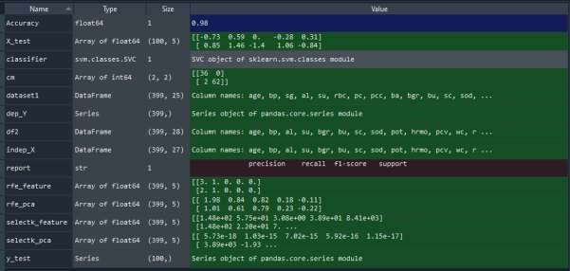
Fig 6.2.1: Support Vector System
LOGISTIC REGRESSION
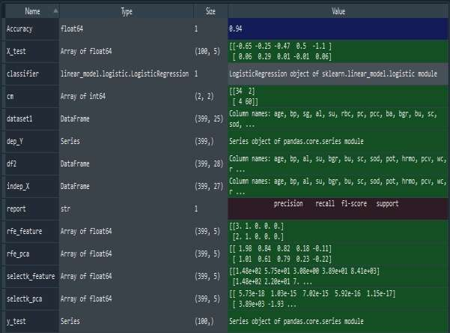

Fig 6.2.2: Logistic Regression

RANDOM FOREST
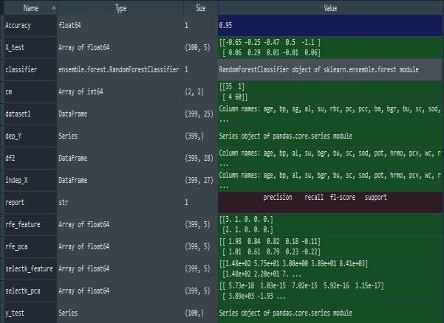
Fig 6.2.3: Random Forest

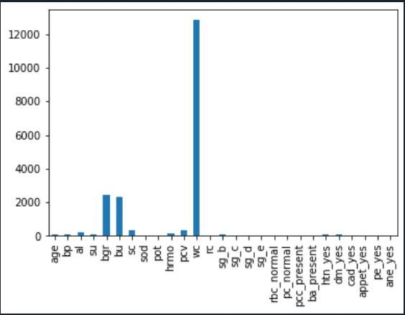
Variable Plot

Fig 6.2.4: Variable Plot

CHAPTER 7

CONCLUSION AND FUTURE ENHANCEMENT

CONCLUSION
Chronic Kidney Disease (CKD) should be diagnosed earlier before kidneys fail to work. To help doctors or medical experts in prediction of CKD among patients easily, this paper has developed a Chronic Kidney Disease Prediction System (CKDPS) using Random Forest Algorithm. Random Forest Algorithm is a machine learning algorithm that combines decision trees to get more accurate and stable prediction.

FUTURE ENHANCEMENTS

- The system can be improved by using larger and more diverse medical datasets to increase prediction accuracy and reliability.
- Advanced deep learning algorithms can be implemented to enhance the performance of disease prediction.
- The model can be integrated with real-time hospital or clinical databases for faster diagnosis.
- A user-friendly web or mobile application can be developed so doctors and patients can easily access the prediction system.
- The system can be expanded to predict multiple diseases, not only Chronic Kidney Disease.
- Integration with IoT-based health monitoring devices can help in collecting real-time patient health data for better analysis.

APPENDIX-A (CODING)

FullProcess.py

  - import pandas as pd
  - dataset1 = pd.read_csv("prep.csv", index_col=None)
  - df2 = dataset1

  - from sklearn.tree import export_graphviz #plot tree
  - from sklearn.metrics import roc_curve, auc #for model evaluation
  - from sklearn.metrics import classification_report #for model evaluation
  - from sklearn.metrics import confusion_matrix #for model evaluation
  - from sklearn.model_selection import train_test_split
  - #X_train, X_test, y_train, y_test = train_test_split(df2.drop('classification_yes', 1), df2['classification_yes'], test_size = .2, random_state=10)

  - import time
  - import pandas as pd
  - import numpy as np
  - from sklearn.preprocessing import StandardScaler
  - from sklearn.feature_selection import SelectKBest
  - from sklearn.feature_selection import chi2
  - from sklearn.model_selection import train_test_split
  - from sklearn.decomposition import PCA
  - from sklearn.feature_selection import RFE
  - from sklearn.linear_model import LogisticRegression
  - import pickle
  - import matplotlib.pyplot as plt

  - df2 = pd.get_dummies(df2, drop_first=True)

  - def selectkbest(indep_X, dep_Y):
  - test = SelectKBest(score_func=chi2, k=5)
  - fit1 = test.fit(indep_X, dep_Y)
  - # summarize scores
  - features = indep_X.columns.values.tolist()
  - np.set_printoptions(precision=2)
  - print(features)
  - print(fit1.scores_)
  - #plt.figure(figsize=(12,3))
  - #plt.bar(fit1.scores_,height=0.6)
  - feature_series = pd.Series(data=fit1.scores_, index=features)
  - feature_series.plot.bar()
  - selectk_features = fit1.transform(indep_X)
  - return selectk_features

  - def rfeFeature(indep_X, dep_Y):
  - model = LogisticRegression(solver='lbfgs')
  - rfe = RFE(model, 5)
  - fit3 = rfe.fit(indep_X, dep_Y)
  - rfe_feature = fit3.transform(indep_X)
  - features = indep_X.columns.values.tolist()
  - #feature_series = pd.Series(data=rfe_feature,index=features)
  - #feature_series.plot.bar()
  - return rfe_feature

  - def pca(features, dep_Y):
  - pca = PCA(n_components=5)
  - fit2 = pca.fit(features)
  - pca_feature = fit2.transform(features)
  - return pca_feature

  - def svm(features, indep_X, dep_Y):
  - X_train, X_test, y_train, y_test = train_test_split(features, dep_Y, test_size=0.25, random_state=0)
  - #X_train, X_test, y_train, y_test = train_test_split(rfe_feature, dep_Y, test_size = 0.25, random_state = 0)
  - #X_train, X_test, y_train, y_test = train_test_split(pca_feature, dep_Y, test_size = 0.25, random_state = 0)
  - #X_train, X_test, y_train, y_test = train_test_split(feature_import, dep_Y, test_size = 0.25, random_state = 0)
  - #X_train, X_test, y_train, y_test = train_test_split(indep_X,dep_Y, test_size = 0.25, random_state = 0)

  - #Feature Scaling
  - #from sklearn.preprocessing import StandardScaler
  - sc = StandardScaler()
  - X_train = sc.fit_transform(X_train)
  - X_test = sc.transform(X_test)

  - # Fitting K-NN to the Training set
  - from sklearn.svm import SVC
  - classifier = SVC(kernel='rbf', random_state=0)
  - classifier.fit(X_train, y_train)

  - # Predicting the Test set results
  - y_pred = classifier.predict(X_test)

  - # Making the Confusion Matrix
  - from sklearn.metrics import confusion_matrix
  - cm = confusion_matrix(y_test, y_pred)

  - from sklearn.metrics import accuracy_score
  - from sklearn.metrics import classification_report
  - #from sklearn.metrics import confusion_matrix
  - #cm = confusion_matrix(y_test, y_pred)

  - Accuracy = accuracy_score(y_test, y_pred)
  - report = classification_report(y_test, y_pred)
  - return classifier, Accuracy, report, X_test, y_test, cm

  - def naives(features, indep_X, dep_Y):
  - #X_train, X_test, y_train, y_test = train_test_split(features, dep_Y, test_size = 0.25, random_state = 0)
  - #X_train, X_test, y_train, y_test = train_test_split(rfe_feature, dep_Y, test_size = 0.25, random_state = 0)
  - #X_train, X_test, y_train, y_test = train_test_split(pca_feature, dep_Y, test_size = 0.25, random_state = 0)
  - #X_train, X_test, y_train, y_test = train_test_split(feature_import, dep_Y, test_size = 0.25, random_state = 0)
  - X_train, X_test, y_train, y_test = train_test_split(indep_X, dep_Y, test_size=0.25, random_state=0)

  - #Feature Scaling
  - #from sklearn.preprocessing import StandardScaler
  - sc = StandardScaler()
  - X_train = sc.fit_transform(X_train)
  - X_test = sc.transform(X_test)

  - # Fitting K-NN to the Training set
  - from sklearn.naive_bayes import GaussianNB
  - classifier = GaussianNB()
  - classifier.fit(X_train, y_train)

  - # Predicting the Test set results
  - y_pred = classifier.predict(X_test)

  - # Making the Confusion Matrix
  - from sklearn.metrics import confusion_matrix
  - cm = confusion_matrix(y_test, y_pred)

  - from sklearn.metrics import accuracy_score
  - from sklearn.metrics import classification_report
  - #from sklearn.metrics import confusion_matrix
  - #cm = confusion_matrix(y_test, y_pred)

  - Accuracy = accuracy_score(y_test, y_pred)
  - report = classification_report(y_test, y_pred)
  - return classifier, Accuracy, report, X_test, y_test, cm

  - def Decision(features, indep_X, dep_Y):
  - X_train, X_test, y_train, y_test = train_test_split(features, dep_Y, test_size=0.25, random_state=0)
  - #X_train, X_test, y_train, y_test = train_test_split(rfe_feature, dep_Y, test_size = 0.25, random_state = 0)
  - #X_train, X_test, y_train, y_test = train_test_split(pca_feature, dep_Y, test_size = 0.25, random_state = 0)
  - #X_train, X_test, y_train, y_test = train_test_split(feature_import, dep_Y, test_size = 0.25, random_state = 0)
  - #X_train, X_test, y_train, y_test = train_test_split(indep_X,dep_Y, test_size = 0.25, random_state = 0)

  - #Feature Scaling
  - #from sklearn.preprocessing import StandardScaler
  - sc = StandardScaler()
  - X_train = sc.fit_transform(X_train)
  - X_test = sc.transform(X_test)

  - # Fitting K-NN to the Training set
  - from sklearn.linear_model import LogisticRegression
  - classifier = LogisticRegression(random_state=0)
  - classifier.fit(X_train, y_train)

  - # Predicting the Test set results
  - y_pred = classifier.predict(X_test)

  - # Making the Confusion Matrix
  - from sklearn.metrics import confusion_matrix
  - cm = confusion_matrix(y_test, y_pred)

  - from sklearn.metrics import accuracy_score
  - from sklearn.metrics import classification_report
  - #from sklearn.metrics import confusion_matrix
  - #cm = confusion_matrix(y_test, y_pred)

  - Accuracy = accuracy_score(y_test, y_pred)
  - report = classification_report(y_test, y_pred)
  - return classifier, Accuracy, report, X_test, y_test, cm

  - def knn(features, indep_X, dep_Y):
  - X_train1, X_test1, y_train, y_test = train_test_split(features, dep_Y, test_size=0.25, random_state=0)
  - #X_train, X_test, y_train, y_test = train_test_split(rfe_feature, dep_Y, test_size = 0.25, random_state = 0)
  - #X_train, X_test, y_train, y_test = train_test_split(pca_feature, dep_Y, test_size = 0.25, random_state = 0)
  - #X_train, X_test, y_train, y_test = train_test_split(feature_import, dep_Y, test_size = 0.25, random_state = 0)
  - #X_train, X_test, y_train, y_test = train_test_split(indep_X,dep_Y, test_size = 0.25, random_state = 0)

  - #Feature Scaling
  - #from sklearn.preprocessing import StandardScaler
  - sc = StandardScaler()
  - X_train = sc.fit_transform(X_train1)
  - X_test = sc.transform(X_test1)

  - # Fitting K-NN to the Training set
  - from sklearn.neighbors import KNeighborsClassifier
  - classifier = KNeighborsClassifier(n_neighbors=5, metric='minkowski', p=2)
  - classifier.fit(X_train, y_train)

  - # Predicting the Test set results
  - y_pred = classifier.predict(X_test)

  - # Making the Confusion Matrix
  - from sklearn.metrics import confusion_matrix
  - cm = confusion_matrix(y_test, y_pred)

  - from sklearn.metrics import accuracy_score
  - from sklearn.metrics import classification_report
  - #from sklearn.metrics import confusion_matrix
  - #cm = confusion_matrix(y_test, y_pred)

  - Accuracy = accuracy_score(y_test, y_pred)
  - report = classification_report(y_test, y_pred)
  - return classifier, Accuracy, report, X_test, y_test, cm

  - def random(features, indep_X, dep_Y):
  - X_train, X_test, y_train, y_test = train_test_split(features, dep_Y, test_size=0.25, random_state=0)
  - #X_train, X_test, y_train, y_test = train_test_split(rfe_feature, dep_Y, test_size = 0.25, random_state = 0)
  - #X_train, X_test, y_train, y_test = train_test_split(pca_feature, dep_Y, test_size = 0.25, random_state = 0)
  - #X_train, X_test, y_train, y_test = train_test_split(feature_import, dep_Y, test_size = 0.25, random_state = 0)
  - #X_train, X_test, y_train, y_test = train_test_split(indep_X,dep_Y, test_size = 0.25, random_state = 0)

  - #Feature Scaling
  - #from sklearn.preprocessing import StandardScaler
  - sc = StandardScaler()
  - X_train = sc.fit_transform(X_train)
  - X_test = sc.transform(X_test)

  - # Fitting K-NN to the Training set
  - from sklearn.ensemble import RandomForestClassifier
  - classifier = RandomForestClassifier(n_estimators=10, criterion='entropy', random_state=0)
  - classifier.fit(X_train, y_train)

  - # Predicting the Test set results
  - y_pred = classifier.predict(X_test)

  - # Making the Confusion Matrix
  - from sklearn.metrics import confusion_matrix
  - cm = confusion_matrix(y_test, y_pred)

  - from sklearn.metrics import accuracy_score
  - from sklearn.metrics import classification_report
  - #from sklearn.metrics import confusion_matrix
  - #cm = confusion_matrix(y_test, y_pred)

  - Accuracy = accuracy_score(y_test, y_pred)
  - report = classification_report(y_test, y_pred)
  - return classifier, Accuracy, report, X_test, y_test, cm

  - indep_X = df2.drop('classification_yes', 1)
  - dep_Y = df2['classification_yes']

  - selectk_feature = selectkbest(indep_X, dep_Y)
  - rfe_feature = rfeFeature(indep_X, dep_Y)

  - selectk_pca = pca(selectk_feature, dep_Y)
  - rfe_pca = pca(rfe_feature, dep_Y)

  - """SVM"""
  - classifier, Accuracy, report, X_test, y_test, cm = svm(selectk_feature, indep_X, dep_Y)
  - classifier, Accuracy, report, X_test, y_test, cm = svm(rfe_feature, indep_X, dep_Y)
  - classifier, Accuracy, report, X_test, y_test, cm = svm(selectk_pca, indep_X, dep_Y)
  - classifier, Accuracy, report, X_test, y_test, cm = svm(rfe_pca, indep_X, dep_Y)

  - """Random Forest"""
  - classifier, Accuracy, report, X_test, y_test, cm = random(selectk_feature, indep_X, dep_Y)
  - classifier, Accuracy, report, X_test, y_test, cm = random(rfe_feature, indep_X, dep_Y)
  - classifier, Accuracy, report, X_test, y_test, cm = random(selectk_pca, indep_X, dep_Y)
  - classifier, Accuracy, report, X_test, y_test, cm = random(rfe_pca, indep_X, dep_Y)

  - """Decision Tree"""
  - classifier, Accuracy, report, X_test, y_test, cm = Decision(selectk_feature, indep_X, dep_Y)
  - classifier, Accuracy, report, X_test, y_test, cm = Decision(rfe_feature, indep_X, dep_Y)
  - classifier, Accuracy, report, X_test, y_test, cm = Decision(selectk_pca, indep_X, dep_Y)
  - classifier, Accuracy, report, X_test, y_test, cm = Decision(rfe_pca, indep_X, dep_Y)

  - """Navies bay"""
  - classifier, Accuracy, report, X_test, y_test, cm = naives(selectk_feature, indep_X, dep_Y)
  - classifier, Accuracy, report, X_test, y_test, cm = naives(rfe_feature, indep_X, dep_Y)
  - classifier, Accuracy, report, X_test, y_test, cm = naives(selectk_pca, indep_X, dep_Y)
  - classifier, Accuracy, report, X_test, y_test, cm = naives(rfe_pca, indep_X, dep_Y)

  - """knn"""
  - classifier, Accuracy, report, X_test, y_test, cm = knn(selectk_feature, indep_X, dep_Y)
  - classifier, Accuracy, report, X_test, y_test, cm = knn(rfe_feature, indep_X, dep_Y)
  - classifier, Accuracy, report, X_test, y_test, cm = knn(selectk_pca, indep_X, dep_Y)
  - classifier, Accuracy, report, X_test, y_test, cm = knn(rfe_pca, indep_X, dep_Y)

Figgy.Py

  - import pandas as pd
  - from sklearn.tree import export_graphviz #plot tree
  - from sklearn.metrics import roc_curve, auc #for model evaluation
  - from sklearn.metrics import classification_report #for model evaluation
  - from sklearn.metrics import confusion_matrix #for model evaluation
  - from sklearn.model_selection import train_test_split
  - #X_train, X_test, y_train, y_test = train_test_split(df2.drop('classification_yes', 1), df2['classification_yes'], test_size = .2, random_state=10)

  - import time
  - import pandas as pd
  - import numpy as np
  - from sklearn.preprocessing import StandardScaler
  - from sklearn.feature_selection import SelectKBest
  - from sklearn.feature_selection import chi2
  - from sklearn.model_selection import train_test_split
  - from sklearn.decomposition import PCA
  - from sklearn.feature_selection import RFE
  - from sklearn.linear_model import LogisticRegression
  - import pickle
  - import matplotlib.pyplot as plt

  - class ckd:
  - def __init__(self):
  - pass

  - def selectkbest(self, indep_X, dep_Y):
  - test = SelectKBest(score_func=chi2, k=5)
  - fit1 = test.fit(indep_X, dep_Y)
  - # summarize scores
  - features = indep_X.columns.values.tolist()
  - np.set_printoptions(precision=2)
  - print(features)
  - print(fit1.scores_)
  - #plt.figure(figsize=(12,3))
  - #plt.bar(fit1.scores_,height=0.6)
  - feature_series = pd.Series(data=fit1.scores_, index=features)
  - feature_series.plot.bar()
  - selectk_features = fit1.transform(indep_X)
  - return selectk_features

  - def pca(self, features, dep_Y):
  - pca = PCA(n_components=5)
  - fit2 = pca.fit(features)
  - pca_feature = fit2.transform(features)
  - return pca_feature

  - def svm(self, features, indep_X, dep_Y):
  - X_train, X_test, y_train, y_test = train_test_split(features, dep_Y, test_size=0.25, random_state=0)
  - #X_train, X_test, y_train, y_test = train_test_split(rfe_feature, dep_Y, test_size = 0.25, random_state = 0)
  - #X_train, X_test, y_train, y_test = train_test_split(pca_feature, dep_Y, test_size = 0.25, random_state = 0)
  - #X_train, X_test, y_train, y_test = train_test_split(feature_import, dep_Y, test_size = 0.25, random_state = 0)
  - #X_train, X_test, y_train, y_test = train_test_split(indep_X,dep_Y, test_size = 0.25, random_state = 0)

  - #Feature Scaling
  - #from sklearn.preprocessing import StandardScaler
  - sc = StandardScaler()
  - X_train = sc.fit_transform(X_train)
  - X_test = sc.transform(X_test)

  - # Fitting K-NN to the Training set
  - from sklearn.svm import SVC
  - classifier = SVC(kernel='rbf', random_state=0)
  - classifier.fit(X_train, y_train)

  - # Predicting the Test set results
  - y_pred = classifier.predict(X_test)

  - # Making the Confusion Matrix
  - from sklearn.metrics import confusion_matrix
  - cm = confusion_matrix(y_test, y_pred)

  - from sklearn.metrics import accuracy_score
  - from sklearn.metrics import classification_report
  - #from sklearn.metrics import confusion_matrix
  - #cm = confusion_matrix(y_test, y_pred)

  - Accuracy = accuracy_score(y_test, y_pred)
  - report = classification_report(y_test, y_pred)
  - return classifier, Accuracy, report, X_test, y_test, cm

  - def random(self, features, indep_X, dep_Y):
  - X_train, X_test1, y_train, y_test = train_test_split(features, dep_Y, test_size=0.25, random_state=0)

  - sc = StandardScaler()
  - X_train = sc.fit_transform(X_train)
  - X_test = sc.transform(X_test1)

  - from sklearn.ensemble import RandomForestClassifier
  - classifier = RandomForestClassifier(n_estimators=10, criterion='entropy', random_state=0, max_depth=5)
  - classifier.fit(X_train, y_train)

  - # Predicting the Test set results
  - y_pred = classifier.predict(X_test)

  - # Making the Confusion Matrix
  - from sklearn.metrics import confusion_matrix
  - cm = confusion_matrix(y_test, y_pred)

  - from sklearn.metrics import accuracy_score
  - from sklearn.metrics import classification_report
  - #from sklearn.metrics import confusion_matrix
  - #cm = confusion_matrix(y_test, y_pred)

  - Accuracy = accuracy_score(y_test, y_pred)
  - report = classification_report(y_test, y_pred)
  - return classifier, Accuracy, report, X_test, y_test, cm, X_test1

  - dataset1 = pd.read_csv("prep.csv", index_col=None)
  - dicc = {'yes': 1, 'no': 0}
  - dataset1['classification'] = dataset1['classification'].replace(dicc)
  - df2 = dataset1

  - df2 = df2.drop('classification', 1)
  - df2 = pd.get_dummies(df2, drop_first=True)
  - indep_X = df2
  - dep_Y = dataset1['classification']

  - obj = ckd()

  - selectk_feature = obj.selectkbest(indep_X, dep_Y)
  - columns = ['bgr', 'bu', 'sc', 'pcv', 'wbc']
  - selectk_feature = pd.DataFrame(selectk_feature)
  - selectk_feature.columns = columns

  - #selectk_pca = obj.pca(selectk_feature, dep_Y)

  - """Random Forest"""
  - classifier, Accuracy, report, X_test, y_test, cm, X_test1 = obj.random(selectk_feature, indep_X, dep_Y)
  - #classifier,Accuracy,report,X_test,y_test,cm=obj.svm(selectk_feature,indep_X,dep_Y)

  - out = classifier.predict([[153, 76, 3.3, 38.8689, 8408.19]])

  - import eli5 #for purmutation importance
  - from eli5.sklearn import PermutationImportance
  - import shap #for SHAP values
  - from pdpbox import pdp, info_plots #for partial plots
  - np.random.seed(123) #ensure reproduc

  - perm = PermutationImportance(classifier, random_state=1).fit(X_test, y_test)
  - print(eli5.format_as_text(eli5.explain_weights(perm)))
  - eli5.show_weights(perm, feature_names=X_test1.columns.tolist())

  - def blockbox(model, patient):
  - explainer = shap.TreeExplainer(model)
  - shap_values = explainer.shap_values(patient)
  - shap.initjs()
  - return shap.force_plot(explainer.expected_value[1], shap_values[1], patient, matplotlib=True, show=False)

  - #Xtestt = pd.DataFrame(X_test1)
  - plt.clf()

  - data = np.array([140, 23, 0.6, 48, 5800])

  - sc = StandardScaler()
  - data = sc.fit_transform(data.reshape(-1, 1))

  - # providing an index
  - ser = pd.DataFrame(data, index=['bgr', 'bu', 'sc', 'pcv', 'wbc'])

  - ss = ser.T.squeeze()
  - #data_for_prediction = X_test1.iloc[0,:].astype(float)
  - #data_for_prediction = obj.pca(np.array(data_for_prediction),y_test)

  - blockbox(classifier, ss)
  - plt.savefig("force_plot.png", dpi=150, bbox_inches='tight')

Base.html

  - {% load static %}

  - <!DOCTYPE html>
  - <html lang="en" dir="ltr">
  - <head>
  - <meta charset="utf-8">
  - <title></title>
  - <meta name="viewport" content="width=device-width, initial-scale=1">
  - <link rel="stylesheet" href="https://maxcdn.bootstrapcdn.com/bootstrap/4.3.1/css/bootstrap.min.css">
  - <link rel="stylesheet" href="/css/style.css">
  - <script src="https://ajax.googleapis.com/ajax/libs/jquery/3.4.1/jquery.min.js"></script>
  - <script src="https://cdnjs.cloudflare.com/ajax/libs/popper.js/1.14.7/umd/popper.min.js"></script>
  - <script src="https://maxcdn.bootstrapcdn.com/bootstrap/4.3.1/js/bootstrap.min.js"></script>
  - <style>
  - body {
  - background-image: url("{% static 'matrix.PNG' %}");
  - background-repeat: no-repeat;
  - /* background-attachment: ; */
  - /* margin-top:300px; */
  - background-size: 40% 100%;
  - }

  - .navbar-default {
  - background-color: #F9CD05;
  - border-color: #F9CD05;
  - }
  - </style>
  - </head>
  - <body>
  - <nav class="navbar navbar-expand-sm navbar-default navbar-dark">
  - <!-- Brand -->
  - <a class="navbar-brand" href="{% url 'ckdApp:ckd' %}">Home</a>

  - <!-- Links -->
  - <ul class="navbar-nav">
  - <li class="nav-item">
  - <a class="nav-link" href="{% url 'ckdApp:ckd' %}">CKD</a>
  - </li>
  - </ul>
  - </nav>
  - <div class="container">
  - {% block body_block %}
  - {% endblock %}
  - </div>
  - </body>
  - </html>

Create.html

  - {% extends 'base.html' %}

  - {% load crispy_forms_tags %}

  - {% block body_block %}

  - <style type="text/css">
  - .jumbotron {
  - background-color: #fff;
  - margin-left: 400px;
  - }
  - </style>

  - <div class="jumbotron">
  - <center>
  - <h1>Chronic Kidney Disease</h1>
  - <head>
  - Please enter repective fields
  - </head>
  - </center>
  - <form method="post" enctype="multipart/form-data">
  - {% csrf_token %}
  - {{ form|crispy }}
  - <center>
  - <button type="submit" class="btn btn-primary">PREDICT</button>
  - </center>
  - </form>
  - </div>

  - {% endblock %}

Success.html

  - {% extends 'base.html' %}
  - {% block body_block %}
  - {% load static %}

  - <style type="text/css">
  - .jumbotron {
  - background-color: #fff0;
  - margin-left: 450px;
  - }
  - .fieldWrapper {
  - font-size: 20px;
  - }
  - </style>

  - <div class="jumbotron">
  - <center>
  - <h1>Chronic Kidney Disease</h1>
  - </center>
  - <div class="fieldWrapper">
  - <center><h2>For the values</h2></center>
  - <p>Blood Glucose Random: {{data_bgr}}</p>
  - <p>Blood Urea: {{data_bu}}</p>
  - <p>Serum Creatine: {{data_sc}}</p>
  - <p>Packed cell volume: {{data_pcv}}</p>
  - <p>White blood count: {{data_wc}}</p>
  - <br>
  - {% if out == 1 %}
  - <p>You <b>will have</b> chronic Kidney Disease in the future: <b>Positive</b></p>
  - {% else %}
  - <p>You <b>will not</b> have chronic Kidney Disease in the future: <b>Negative</b></p>
  - {% endif %}
  - <br>
  - <br>
  - <img class="mx-auto d-block" style="width: 900px; height: 450px" alt="posneg" src="{% static 'force_plot.png' %}"/>
  - <br>
  - <br>
  - <a href="{% url 'ckdApp:ckd' %}">CKD Predicition</a>
  - <br>
  - </div>
  - </div>

  - {% endblock %}

REFERENCES

[1] A. K. Singh et al., “Chronic Kidney Disease Prediction Prediction Using Random Forest and Support Vector Machine,” IEEE Transactions on Neural Networks and Learning Systems, 2022.

[2] A. Gupta et al., “Improving CKD Prediction Accuracy Using Ensemble Learning,” Expert Systems with Applications, 2023.

[3] B. Das et al., “Early Detection of CKD Using Classification Algorithms,” International Journal of Computer Applications, 2021.

[4] D. Roy et al., “Predictive Analytics for Chronic Diseases Using AI Models,” IEEE Transactions on Artificial Intelligence, 2024.

[5] F. Ahmed et al., “Data-Driven Approach for CKD Prediction Using AI,” IEEE Access, 2023.

[6] G. Nandhini and J. Aravinth, “Chronic Kidney Disease Prediction Using Machine Learning Techniques,” IEEE International Conference on Recent Trends on Electronics, Information, Communication and Technology, 2021.

[7] H. Kim et al., “Healthcare Prediction Systems Using Machine Learning Techniques,” IEEE Access, 2021

[8] J. Liu et al., “Machine Learning-Based Chronic Kidney Disease Prediction Using Electronic Health Records,” IEEE Journal of Biomedical and Health Informatics, 2023.

[9] K. Reddy et al., “Feature Selection-Based CKD Prediction Using Machine Learning,” IEEE Access, 2022.

[10] L. Wang et al., “Deep Learning Models for Chronic Disease Prediction,” IEEE Journal of Biomedical and Health Informatics, 2024.

[11] M. Sharma et al., “A Comparative Study of Machine Learning Algorithms for CKD Prediction,” IEEE Access, 2022.
.
[12] N. Ali et al., “Machine Learning-Based Medical Diagnosis Systems,” Journal of Medical Systems, 2022.

[13] P. Kumar et al., “Chronic Kidney Disease Prediction Using Data Mining Techniques,” International Journal of Advanced Computer Science, 2021.

[14] R. Patel et al., “Artificial Intelligence-Based Early Detection of Chronic Kidney Disease,” Journal of Healthcare Informatics Research, 2025

[15] S. Verma et al., “Efficient Prediction of CKD Using Hybrid Machine Learning Models,” IEEE Transactions on Biomedical Engineering, 2023.

[16] S. Singh et al., “Predicting Chronic Kidney Disease Using Machine Learning Algorithms,” IEEE Journal of Biomedical and Health Informatics, 2021.

[17] T. Nagamani, R. Kavya, D. Lavanya, and S. Miruthula, “Chronic Kidney Disease Prediction Using Machine Learning Algorithms,” International Conference on Advances in Modern Age Technologies for Health and Engineering Science (AMATHE), IEEE, 2024.

[18] Y. Chen et al., “Intelligent Healthcare Systems for Disease Prediction,” IEEE Transactions on Neural Networks and Learning Systems, 2025.

[19] X. Zhang et al., “Advanced Machine Learning Techniques for Chronic Kidney Disease Prediction,” IEEE Access, 2024.

